Strategic Planning Process Pie Graph - Long Description

In this pie graph, you can click on pieces of the pie to learn more about the different parts of the School of Education (SOE) strategic planning process. Below is a description of what appears in this graphic when each piece of the pie is clicked on. 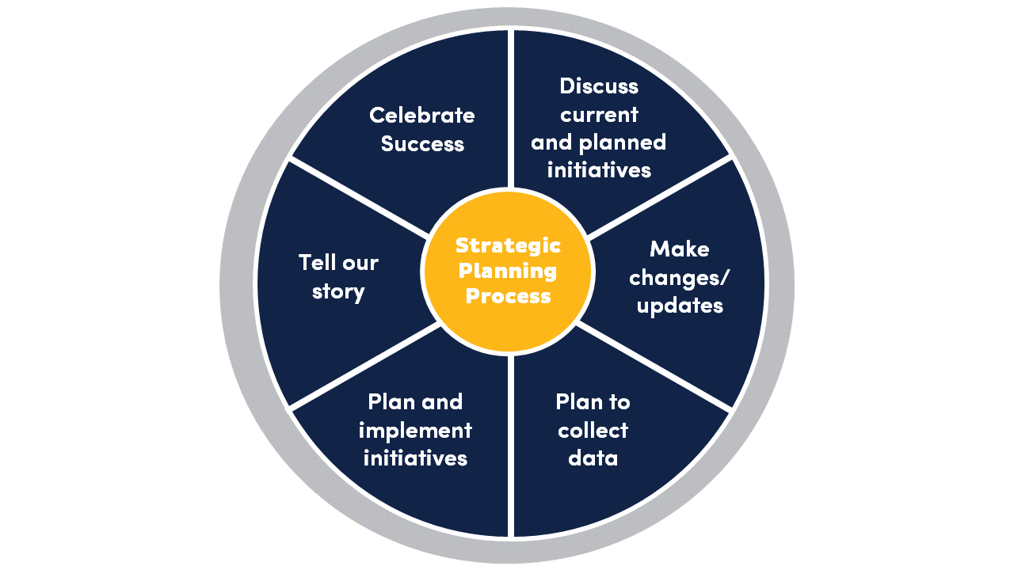
Discuss current and planned initiatives
- More in-depth information that is displayed when you hover the mouse over this slice of the circle: Review and share information about work/initiatives that are already occurring or planned

Make changes/updates
- More in-depth information that is displayed when you hover the mouse over this slice of the circle: Make modifications/updates to strategic plan targets, plans, etc. where necessary

Plan to collect data
- More in-depth information that is displayed when you hover the mouse over this slice of the circle: Evaluate data collection methods; modify/build data collection mechanisms related to strategic plan targets/outcomes- where needed.

Plan and implement initiatives
- More in-depth information that is displayed when you hover the mouse over this slice of the circle: Make/update action plans or implementation plans; support or provide resources for the implementation of programs, initiatives, activities, opportunities, etc. that are aligned to strategic plan targets/outcomes.

Tell our story
- More in-depth information that is displayed when you hover the mouse over this slice of the circle: Collect and use data to tell the story of how we are carrying out our strategic plan and achieving our strategic plan goals; collect and use data to further improve the initiatives we are implementing.

Celebrate Success
- More in-depth information that is displayed when you hover the mouse over this slice of the circle: Celebrate and highlight areas where we “moved the needle” toward achieving our strategic planning goals or areas where we demonstrated improvement.

